 Translated from Chinese (Simplified) to English - www.onlinedoctranslator.com

IDH57
Integrated pulse open loop stepper driver

User Manual V1.0.1

Table of contents
one,Product Introduction 1
1.1 Product Overview 1
1.2 Product Features 1
1.3 Application Areas 1
two,Electrical, Mechanical and Environmental Specifications 2
2.1 Mechanical installation diagram 2
2.2 Installation Notes 2
2.3 Electrical specifications 3
2.4 Operating environment and parameters 3
three,Driver interface and wiring introduction 3
3.1 Interface Diagram 3
3.2 Interface Description 4
3.2.1 Control signal interface 4
3.2.2 Output signal interface 4
3.2.3 RS485 interface 4
3.2.4 Motor control output interface 5
3.2.5 Power Input Interface 5
3.2.6 Burning and debugging interface 5
3.2.7 Status Indicator 5
3.3 Input control signal 6
3.3.1 Input control signal interface circuit 6
3.3.2 Control signal timing diagram 6
3.3.3 Control signal mode setting 7
3.4 Output control signal 7
3.4.1 Used for alarm and arrival output 7
3.4.2 Used as a brake control motor 8
3.5 Wiring requirements 9
Four,DIP switch function setting 9
4.1 Current Setting 9
4.2 Segmentation Settings 10
five,Power supply selection 10
six,Indicator lights and alarm indicators 11
seven,Warranty and after-sales 12
7.1 Warranty 12
7.1.1 Free warranty 12
7.1.2 Warranty exclusion 12
7.2 Exchange 12
7.2.1 Replacement of defective product 12
7.2.2 Exchange for non-product failure 13
7.3 Returns 13
7.4 After-sales service 13
eight,Revision History 14

Product Introduction

1.1 Product Overview
IDH57 integrated pulse open-loop stepper driver is a newly launched new type of integrated motor driver. It adopts the latest dedicated motor control digital signal processor to improve the overall performance of the motor, reduce the heating level of the motor and reduce the vibration of the motor. It adopts an integrated design of motor and driver, which makes the installation more compact and reduces external interference.
IDH57 has serial port debugging function and uses MINI USB interface for communication. Users can set various parameters such as subdivision, current, working mode, etc. through the host computer debugging software, which greatly enriches the practical functions of the product and can meet the application of most occasions.

1.2 Product Features
●Integration of motor and drive saves wiring labor
●Small size, easy to install
●New generation 32-bit DSP technology, good stability, strong compatibility and high cost performance
●External dial to set the driver current and subdivision
Optically isolated differential signal input
●Built-in micro-segmentation, excellent low-speed stability
●The impulse response frequency can reach up to 200KHz (higher can be modified)
●Subdivision setting range 200-60000 (can be set by the host computer)
●Precise current control greatly reduces motor heating
●Low vibration and low noise
●With overvoltage, undervoltage, phase loss and other alarm protection functions
Input voltage range:DC12V~50V

1.3 Application Areas
Suitable for various small and medium-sized automation equipment and instruments, such as medical equipment, testing equipment, marking machines, plotters, etc. It meets customers' requirements for low noise, low heat generation, convenient wiring, and stronger anti-interference.

Electrical, Mechanical and Environmental Specifications

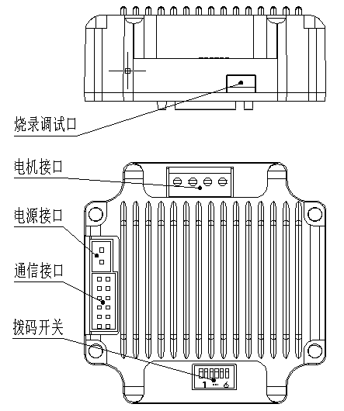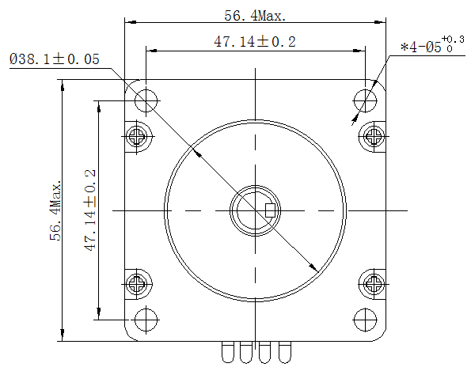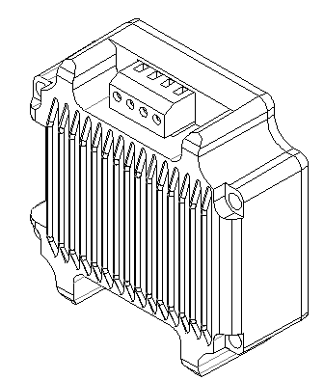2.1 Mechanical installation diagram

Figure 2.1 Installation dimensions (unit: mm)

2.2 Installation Notes
- When installing the integrated stepper driver, do not knock on the rear end cover of the motor to avoid affecting the operating performance. When designing the installation dimensions, the size and wiring of the wiring terminals must be considered.
- In order to ensure good heat dissipation conditions, a larger installation interval must be reserved as much as possible during actual installation.If multiple integrated drives are installed side by side, fans can be installed to create strong air convection on the surface of the integrated drives to assist in heat dissipation and ensure that the drives operate within a reliable operating temperature range.

2.3 Electrical specifications
illustrate | IDH57
illustrate | Minimum | Typical Value | Maximum | unit
Input power voltage | 12 | twenty four | 50 | VDC
Control signal input current | 7 | 10 | 16 | mA
Step pulse frequency | 0 | - | 200 | KHz
Insulation resistance | 50 |  |  | MΩ

2.4 Operating environment and parameters
Cooling method |  | Natural cooling, fan cooling
Usage Environment | occasion | Do not place it near other heating equipment. Avoid dust, oil mist, corrosive gas, high humidity and strong vibration. Flammable gas and conductive dust are prohibited.
Usage Environment | temperature | 0——50℃
Usage Environment | humidity | 40-90%RH
Usage Environment | vibration | 10~55Hz/0.15mm
Storage temperature |  | -20℃~65℃

Driver interface and wiring introduction

3.1 Interface Diagram
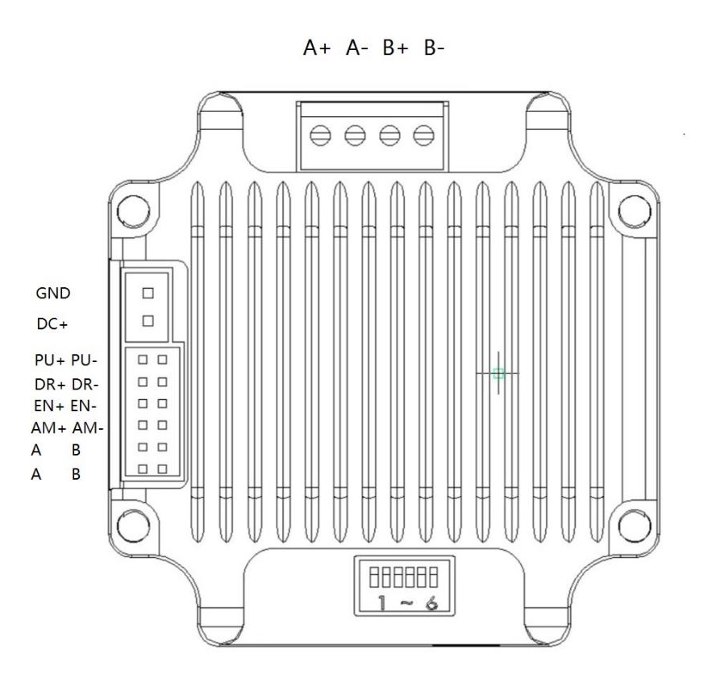
Figure 3.1 IDH57 interface diagram

3.2 Interface Description
The power interface of IDH57 integrated pulse open-loop stepper driver adopts XH2.54-2P pin socket, the signal control interface adopts PHB2.0-6P pin socket, and the motor interface adopts 3.5-4P pin socket. They are correctly wired at the factory. The specific definition of the interface is described in the following sections.

3.2.1 Control signal interface
name | Function
PU+ | Pulse control signal: +5V-+24V can be driven, rising edge is effective, every time the pulse isLowChangehighThe motor takes one microstep. In order to reliably respond to the pulse signal, the pulse width should be greater than 2.5μs.
PU-
DR+ | Direction control signal: +5V-+24V can be driven, high/low level signal. To ensure reliable commutation of the motor, the direction signal should precede the pulse signal by at least 50μs established.
DR-
EN+ | Enable control signal: +5V-+24V can be driven, high/low level signal. Used to enable or disable the operation of the motor. When EN+ is connected to +5V and EN- is connected to a low level, the driver will cut off the current of each phase of the motor to put the motor in a free state, and the step pulse will not be responded to at this time. When this function is not needed, the enable signal terminal can be left floating. In addition, the EN terminal can also be used to clear the out-of-tolerance alarm signal.
EN-

3.2.2 Output signal interface
The output signal interface is used as an alarm output function by default. When an overvoltage, undervoltage, phase loss, or position error alarm occurs, the output signal is valid. In addition, the output interface can also be set to in-position output or brake control output through the PC host software. Users can make corresponding settings according to actual usage.
name | Function
AM+ | Alarm signal output: When overvoltage or undervoltage alarm occurs, the alarm signal output is valid;  For normally open or normally closed connection, see the description in Section 3.4;  Maximum driving current 50mA.
AM-

3.2.3 RS485 interface
name | Function
AB | 485 communication interface A and B terminals, reserved ports, this model does not support RS485, no need to connect
AB | 485 communication interface A and B terminals, reserved ports, this model does not support RS485, no need to connect

3.2.4 Motor control output interface
name |  | color | illustrate | Function
Motor | A+ | red | Motor interface | Two-phase stepper motor wiring port, please pay attention to the line sequence;  If you want the opposite initial rotation direction, just swap A+ and A- or swap B+ and B-;  The wiring has been correctly done at the factory. If it is not necessary, please do not change the wiring sequence at will.
Motor | A- | blue | Motor interface
Motor | B+ | green | Motor interface
Motor | B- | black | Motor interface

3.2.5 Power Input Interface
name |  | illustrate | Function
VDC | DC+ | Power interface | Power Input  DC12V~50V
VDC | GND | Power interface | Power Input  DC12V~50V

3.2.6 Burning and debugging interface
The serial communication interface of IDH57 driver adopts MINI USB interface, which can be connected to PC through the dedicated debugging line provided by our company via USB to TTL serial port conversion tool. Do not plug and unplug with power on! On the PC side, customers can set the required parameters, such as current, subdivision, working mode, etc. For details, please refer to the upper computer software interface.
Terminal No. | symbol | name | illustrate
1 | NC | - | Internal Use
2 | NC | - | Internal Use
3 | GND | RS232 communication ground | 0V
4 | NC | - | Internal Use
5 | NC | - | Internal Use
6 | NC | - | Internal Use
7 | RxD | RS232 Receiver
8 | TXD | RS232 transmitter
▶Note: The debugging line connecting IDH57 and PC is a dedicated line (provided according to user needs). Please check before use to avoid damage.

3.2.7 Status Indicator
The indicator light of IDH57 integrated pulse open-loop stepper driver is a retracted SMD LED, and its basic definition is shown in the following table.
name | Function | illustrate
Green LED | Power supply, parameter saving function indication, factory reset function indication, dial status switching indication,  Alarm indicator light | When the power is on normally, the green light is always on and the red light is off. When saving parameters, restoring factory settings, switching the dial status, or when the device is abnormal, the red and green lights flash alternately to alarm. For the flashing rules, please refer to Chapter 6;
Red LED

3.3 Input control signal

3.3.1 Input control signal interface circuit
The IDH57 driver control signal end adopts a differential interface circuit, which is applicable to differential signals, single-ended common cathode and common anode interfaces. It has a built-in high-speed photocoupler and has strong anti-interference ability in harsh environments. The interface circuit diagram is shown in Figure 3.2.
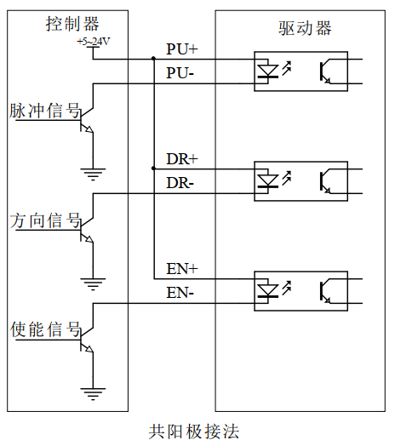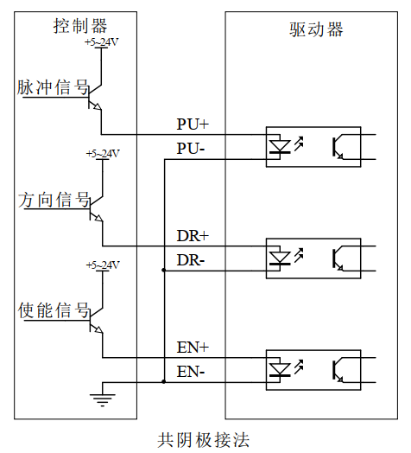
Figure 3.2 Input interface circuit
▶Note: IDH57 is a 5V-24V universal driver, so the signal control end does not need a series resistor!

3.3.2 Control signal timing diagram
In order to avoid some malfunctions and deviations, PU, ​​DR and EN should meet certain requirements, as shown in the following figure:
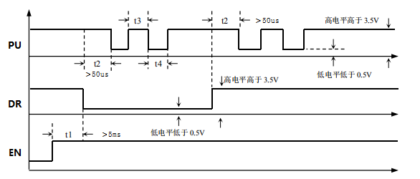
Figure 3.3 Control signal timing diagram
Notes:
- t1: EN (enable signal) should be at least 5ms ahead of DR and confirmed to be high. In general, it is recommended that EN+ and EN- be left floating.
- t2: DR is at least 5 seconds ahead of the falling edge of PU0μs determines its state high or low.
- t3: The pulse width is at least 2.5μs.
- t4: Low level width is not less than 2.5μs.

3.3.3 Control signal mode setting
Pulse trigger edge selection: The rising edge or falling edge of the pulse can be set to trigger effectively through the PC software.

3.4 Output control signal
After the driver is powered on normally, the effective state of the output interface is initially defaulted to normally open output.The user can also configure the effective state of the output interface through the master station, and the initial default is normally closed output.

3.4.1 Used for alarm and arrival output
The following figure is a wiring diagram for the output signal port when used as an alarm output function (the connection method is the same when used as a position output):
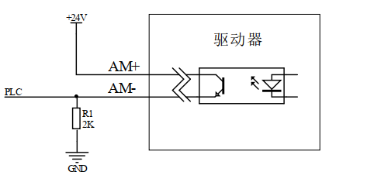
Figure 3.4 Schematic diagram of normally closed connection of output interface
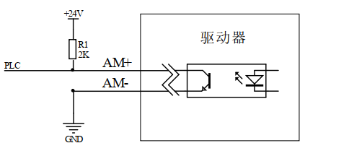
Figure 3.5 Schematic diagram of normally open connection of output interface

3.4.2 Used as a brake control motor
The output port of IDH57 integrated open-loop stepper driver includes the control function of the brake motor brake. Users only need to set the output port function to 'brake control signal' through the PC host debugging software, and then they can control the brake motor brake through the AM+ and AM- ports.
The following figure is a wiring diagram of the brake motor brake device. The relevant parameter descriptions are described in the following table:
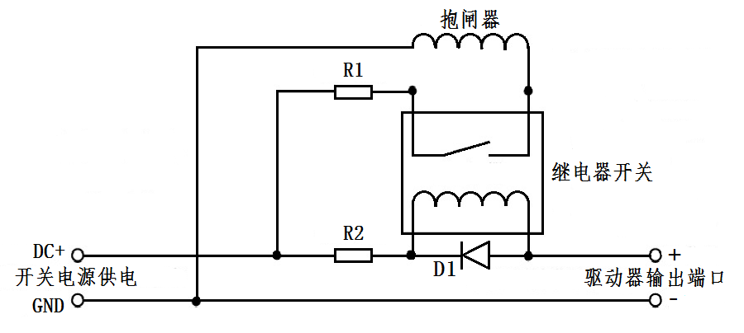
Figure 3.6 Brake motor brake wiring diagram

name | Logo | illustrate
Switching power supply | DC+ | Connect to +24 or +5V power supply
Switching power supply | GND | Ground terminal
Driver output port | AM+ | Output port +
Driver output port | AM- | Output port - end
Protection resistor | R1 | If the brake is powered by DC24V, R1 can be smaller or not connected; if the brake is powered by DC5V, R1 should be larger;
Protection resistor | R2 | R2 can be connected to a 1~2K resistor to limit the current to prevent damage to the optocoupler components inside the driver;  You can refer to the relay specification to determine whether it needs to be connected;
Freewheeling diode | D1 | Protect the internal components of the driver from being damaged by induced voltage. Please refer to the relay specification to determine whether it is necessary to connect;
Brake |  | The control mechanism with brake motor is generally in the release state after the power is turned on, and the motor can run freely. Before use, you need to confirm its power supply voltage to avoid excessive voltage burning the brake device;

3.5 Wiring requirements
- In order to prevent the driver from being interfered, it is recommended that the control signal use shielded cable, and the shield layer is short-circuited with the ground wire. Except for special requirements, the shield line of the control signal cable is grounded at one end: the host computer end of the shield line is grounded, and the driver end of the shield line is suspended. Only the same point is allowed to be grounded in the same machine. If it is not a real ground wire, there may be serious interference. In this case, the shield layer is not connected.
- The pulse and direction signal lines are not allowed to be wrapped side by side with the motor lines. It is best to separate them by at least 10 cm. Otherwise, the motor noise will easily interfere with the pulse direction signals and cause inaccurate motor positioning, system instability and other faults.
- If one power supply supplies multiple drives, they should be connected in parallel at the power supply. Chain connection from one drive to another is not allowed.
- It is strictly forbidden to plug or unplug the high-voltage terminals of the driver while it is powered on. When the motor is stopped, there is still a large current flowing through the coil. Plugging or unplugging the terminals while it is powered on will cause a huge instantaneous induced electromotive force that will burn out the driver.
- It is strictly forbidden to connect the wire end to the terminal after tinning it, otherwise the contact resistance may increase and the terminal may be damaged by overheating.
- The wiring ends must not be exposed outside the terminals to prevent accidental short circuits and damage to the driver.

DIP switch function setting
The IDH57 driver uses a 6-position dip switch, SW1-SW2 is used for current setting, and SW3-SW6 is used for subdivision setting. The detailed description is as follows:
SW1 | SW2 | SW3 | SW4 | SW5 | SW6
Current setting |  | Segment settings

4.1 Current Setting
SW1-SW2 sets the output current of the driver. The DIP switches correspond to the default current settings, as shown in the table below. You can also set the current size corresponding to each current level independently through the PC software.
SW1 | SW2 | Open Loop |  | illustrate
SW1 | SW2 | Peak(A) | RMS(A) | illustrate
off | off | 2.1 | 1.5 | Users can independently set the current size of each gear through the PC software, unit: mA;
on | off | 2.8 | 2.0
off | on | 3.5 | 2.5
on | on | 4.4 | 3.1

4.2 Segmentation Settings
SW3-SW6 sets the subdivision of the driver. There are 16 subdivisions that can be set. You can also set the subdivision size corresponding to each subdivision independently through the PC software. The dial corresponds to the default subdivision setting, as shown in the following table:
Steps/turn | SW3 | SW4 | SW5 | SW6 | illustrate
200 | on | on | on | on | Users can independently set the size of each subdivision through the PC software, with a setting range of 200-60000.The resolution is 1.
400 | off | on | on | on
800 | on | off | on | on
1600 | off | off | on | on
3200 | on | on | off | on
6400 | off | on | off | on
12800 | on | off | off | on
25600 | off | off | off | on
1000 | on | on | on | off
2000 | off | on | on | off
4000 | on | off | on | off
5000 | off | off | on | off
10000 | on | on | off | off
20000 | off | on | off | off
3600 | on | off | off | off
7200 | off | off | off | off

Power supply selection
The power supply voltage can work normally within the specified range. The IDH57 driver is best powered by a regulated DC switching power supply. It should be noted that the output current range of the switching power supply must be set to the maximum. An unregulated DC power supply can also be used, but it should be noted that the peak value of the rectified voltage ripple should not exceed the specified maximum voltage. It is recommended that users use a DC voltage lower than the maximum voltage to avoid grid fluctuations exceeding the driver voltage operating range.
▶Note:
- When wiring, pay attention to the positive and negative poles of the power supply and do not connect them in reverse;
- When wiring, pay attention to the position of the power interface and do not connect it to the motor port. After connecting, it is best to confirm whether it is connected correctly;
- It is best to use a regulated DC switching power supply;
- When using an unregulated DC power supply, the power supply current output capacity should be greater than 60% of the driver set current;
- When using a regulated DC switching power supply, the output current of the power supply should be greater than or equal to the operating current of the driver;
- To reduce costs, two or three drivers can share one power supply, but the power supply must be large enough.

Indicator lights and alarm indicators
IDH57 integrated pulse open-loop stepper driver has a green LED and a red LED. One can be used as a power indicator, and the other can be used as a fault indicator, a DIP switch indicator, or a parameter save or restore indicator. The specific relationship is shown in Table 6.1 below:
When the driver is powered on, the green LED is always on, and when the driver is powered off, the green LED is off.
When the DIP switch is turned, the green LED will flash twice quickly. This is normal and indicates that the DIP state switch is valid.
When the drive fails, the red and green lights flash alternately, and different flashing patterns indicate different fault information. When the fault is eliminated by the user, the green LED remains on and the red LED goes out.
When saving/restoring parameters, the red and green lights flash alternately in a cycle. When saving/restoring parameters is completed, the green LED is always on and the red LED is off.
Table 6.1 LED status indication
Number of LED flashes |  | Phenomenon | illustrate
Green LED | Red LED | After the green light flashes, the red light flashes
0 | - | Green light is always on, red light is off | Driver Enable
1 | - | Green light flashes, red light off | Receive pulse signal
1 | 1 |  | Normal out-of-tolerance alarm (reserved)
2 | 1 |  | Pulse received in disabled state
3 | 1 |  | (Overpressure) out-of-tolerance alarm (reserved)
4 | 1 |  | (Undervoltage) out-of-tolerance alarm (reserved)
1 | 4 |  | Overpressure alarm
2 | 4 |  | Undervoltage alarm
1 | 5 |  | Overcurrent alarm (reserved)
1 | 6 |  | AB phase loss alarm
2 | 6 |  | Only A phase missing alarm
3 | 6 |  | Only phase B is missing.
1 | 8 |  | Timeout alarm in homing mode (reserved)
1 | 2 |  | Restoring parameters
2 | 2 |  | Saving parameters in progress

Warranty and after-sales

7.1 Warranty

7.1.1 Free warranty
Our company solemnly promises that if any of our products are damaged during use due to the product itself, we will provideOne yearFree repair service. The shipping cost of the product shall be borne by both parties.

7.1.2 Warranty exclusion
- The driver is damaged due to the customer's own wiring error;
- The drive is damaged due to exceeding the rated working voltage;
- The DC power supply driver is connected to the AC power supply, causing the driver to be damaged;
- The driver is damaged due to the customer's extremely harsh on-site environment, such as humidity, extreme cold, extreme heat, etc., without informing our company in advance;
- The customer dismantles the drive housing without permission or the serial label number is torn off;
- 15 days after the customer confirms receipt, the housing is obviously damaged or hit, resulting in damage to the drive;
- Forceful natural disasters, such as fire, earthquake, tsunami, typhoon, etc.;
In the above cases, our company will charge a certain amount of repair cost after evaluating the interests of all parties. In other cases, repairs will be provided free of charge forever.

7.2 Exchange

7.2.1 Replacement of defective product
For faults in new products, our company provides three months of free replacement service.
After our technical support staff confirms that the problem is with the product itself, they will send the product back to our company to avoid wasting time and postage on the round trip. Customers need to send the faulty product back by express or logistics first, and our company will send another new product back to the customer as soon as possible after receiving it.
Notice:All our products undergo rigorous testing and aging before leaving the warehouse, so it is extremely rare for new products to malfunction. Please be sure to read the instructions carefully or consult our technical support staff when operating, or our technical support staff will remotely assist customers in operating.
- Please note the following points when exchanging goods:
(1) Please ensure that the package is complete when sending it back to avoid damage during transportation;
(2) Please ensure that the attached accessories are complete when exchanging the product;
(3) Each driver should be packaged independently in its original outer box to avoid secondary damage to the product during transportation;
(4) If the driver is returned and it is confirmed that the fault is not due to product failure, but rather due to the customer's negligence in operation, which led to the customer mistakenly thinking that the driver is faulty, the company will not bear the shipping costs (the customer's negligence in operation includes: the driver is damaged due to wrong wiring, the driver is mistakenly thought to be damaged due to poor wiring, the driver cannot be used normally due to operation errors, etc.).

7.2.2 Exchange for non-product failure
If the customer is not satisfied with the appearance or function of the product received and wants to replace it with a better driver, he or she can apply for a replacement service from our company within one week of receiving the product. After verification, our company will return the product. If the returned product is confirmed to be undamaged, with complete accessories and good packaging, the company will replace it with another product for the customer. For the replaced product, if there is a price difference, the customer will make up the difference.
Note: The replaced product will no longer be eligible for the non-product fault replacement service. The round-trip shipping costs and other costs incurred by the non-product fault replacement service shall be borne by the customer!

7.3 Returns
Our company provides a 7-day return service for products with quality problems. If you find quality problems with the product within 7 days of receiving the product (based on the actual date of receipt by the customer), please communicate with our salesperson or technical support personnel in time. After our technical support personnel confirms that it is a quality problem of the company's product itself, the customer can send the original complete product and its inner and outer packaging, accessories and shipping order back to our company by express or logistics.
If the customer still insists on returning the goods after our company has checked and confirmed that they are correct, the round-trip shipping costs and all other costs incurred shall be borne by the customer.
- Please note the following points when returning goods:
(1) Please contact the relevant department of our company before making a refund;
(2) The product must be in new condition and intact packaging. Please send it back to our company by express or logistics;
(3) We will not accept any complaints caused by customers, such as product appearance damage, incomplete accessories, etc.

7.4 After-sales service
If customers encounter technical problems when using this product, please contact our company as soon as possible. Please call our national free service hotline: 0755-23206995.
Service hours: 8:30-17:30, Monday to Friday (except national holidays).

Revision History
Version Number | illustrate | Modify deadline | Preparer/Reviewer
V1.0.0 | Initial use version; | 2022.06.01 | TCJ, JQ/XH
V1.0.1 | Optimize some details;  Add company logo; | 2022.7.19 | TCJ/XH

